3. Lean-based Lab Experimentation

1.Create a new project and select a company-managed project.

2. Add issue type and description.

3. Add the created issue types to the screens.

4.Now check the custom fields for the issues

5.Choose a field type for the different status.

6.For reference, name the field as Experiment and customize the selection tab.

7.Now create a epic and provide the proper summary.

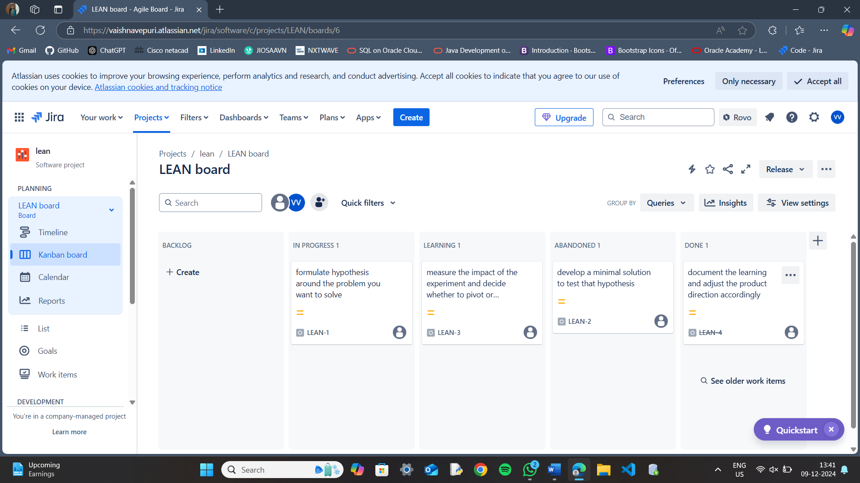

8.Finally check the list of issues in progress, to do and complete state.

